Efficient Hyperparameter Strategies: A Grid vs Random Study on FiReCS
Justin Clark A. Posadas
Computer Studies and Engineering
Jose Rizal University
Mandaluyong City, Philippines
justinclark.posadas@my.jru.edu

Abstract— This paper reports an automated hyperparameter tuning study for Taglish sentiment classification using the FiReCS dataset. The goal was to compare Grid Search and Random Search in terms of speed and performance while keeping the setup practical for classroom and small-GPU settings. The workflow included data cleaning, reproducible 80/10/10 splits, tokenization with a Transformer backbone, a TF–IDF + Logistic Regression baseline, and fine-tuning with Hugging Face Trainer. We used Optuna to drive the two search strategies over learning rate, batch size, weight decay, warmup, and short epoch budgets. Evaluation focused on macro-F1 to treat the three classes fairly, with confusion matrices and classification reports for added insight. All runs were logged to a consolidated sheet for later analysis. Results show that both strategies reached very similar macro-F1, indicating a stable and forgiving search region. Grid Search achieved a slightly higher best and mean macro-F1, and required less total wall-clock time because the grid was small and well bounded. Random Search produced near-matching scores with slightly lower time per trial but higher total time due to more trials. The strongest settings were simple and repeatable: learning rate near 3e-5, moderate weight decay, batch sizes of 16 or 8 depending on memory, and warmup around 250 steps with a linear or cosine scheduler. We conclude that Grid Search is efficient for small, discrete spaces, while Random Search is preferable when the space becomes larger or more continuous.
Keywords— FiReCS, Taglish sentiment analysis, hyperparameter tuning, Grid Search, Random Search, Optuna, Transformer fine-tuning, macro-F1, Hugging Face, automated optimization

INTRODUCTION
The Philippine e-commerce sites depend on customer reviews which are usually written in Tagalog-English code-switching language containing local slangs, emojis, and marketplace lingo. Misreading These reviews are often misread by tools which are largely trained on monolingual English and fail to provide useful concerns which buyers and sellers are often interested in e.g. delivery speed, quality of packaging, size and fit, price to value and communication with the seller. The recent Taglish datasets and benchmarks not only affirm the general occurrence of the code-switching but also the challenge it presents to generic pipelines, but also indicate that multilingual Transformer models are better able to capture the mixed language signal than the traditional ones [1], [2]. Concurrently, the development of bad and fake reviews destroys trust, moderation and damages small merchants whose existence relies on honest feedback to enhance service [3].
The goal of this exercise is to improve a Transformer sentiment classifier through automated hyperparameter tuning. We compare two common search strategies: Grid Search and Random Search. Grid Search tries all combinations from a small set of values, while Random Search samples values from defined ranges. We track speed and performance for each strategy and record all results in a shared experiment log. The focus is on macro-F1 since the task involves three classes and we want balanced performance across them. We also keep training practical by using short runs, early stopping, and GPU-aware settings where available.
We use the FiReCS dataset from Hugging Face, which contains Taglish product reviews labeled as negative, neutral, and positive. The data is cleaned, split into train, validation, and test sets, then tokenized for the selected Transformer backbone. After tuning, we evaluate the best settings on the test set and export confusion matrices, prediction files, and summary tables. The final section compares Grid and Random based on validation macro-F1 and total time, then recommends the more suitable approach for this dataset size and search space.

Methodology

Dataset and Task Framing

FiReCS is a sentiment dataset of Filipino–English code-switched reviews for products and services. It contains 10,487 reviews written in Taglish and labeled into three classes: negative, neutral, and positive. Labels are stored as integers with the encoding 0 = negative, 1 = neutral, 2 = positive. The dataset creators report high inter-annotator agreement with Krippendorff’s alpha = 0.83, and the overall distribution is fairly balanced across classes.

Reviews were gathered from Google Maps and Shopee Philippines. Three human annotators who are native Filipino speakers and fluent in English performed the labeling, with a third annotator resolving disagreements. The dataset card also provides ready counts for an example split: train (7,340 reviews) and test (3,147 reviews). FiReCS is released under CC-BY-4.0, and the dataset page lists Filipino and English as the covered languages. The page also notes a related four-class successor called SentiTaglish: Products and Services.

Environment Setup and Imports

Here we use Google Colab as a cloud notebook so the whole workflow runs in a clean, Linux-based Python environment with ready access to GPUs. Colab lets us install exact library versions at the top of the notebook, mount Google Drive for persistent files, and enable a CUDA GPU for faster training. We set a random seed for reproducibility, print the device info to confirm the GPU, and tune batch sizes and mixed precision (fp16) based on the available memory. To keep results consistent across runs, we save our fixed split IDs and all experiment logs to Drive. We also export artifacts such as predictions, confusion matrices, best checkpoints, and ONNX files. Since Colab sessions have limited RAM and can time out, we keep trials short, free GPU memory between runs, and cache tokenizers and models in the runtime to balance speed and stability.
This notebook starts by preparing a clean Python environment for NLP experiments. It installs and imports the core libraries used for data handling, modeling, and evaluation. The key tools are pandas and numpy for tables and arrays, scikit-learn for classic baselines and metrics, and Hugging Face transformers and datasets for tokenization, model loading, training, and batched data pipelines. Matplotlib is included for plots like the confusion matrix. The code also checks if a GPU is available and sets device flags. This lets the notebook scale from CPU-only runs to faster GPU runs without code changes.

The imports are grouped by purpose to keep the notebook readable. One block holds cleaning and regex utilities, another block holds modeling and tokenization utilities, and another block holds evaluation helpers. The notebook also defines small helper functions, such as a metrics function that returns accuracy and macro-F1, and it sets seeds for reproducibility. These details ensure that results are consistent across runs and that later cells can reuse the same utilities without duplication.

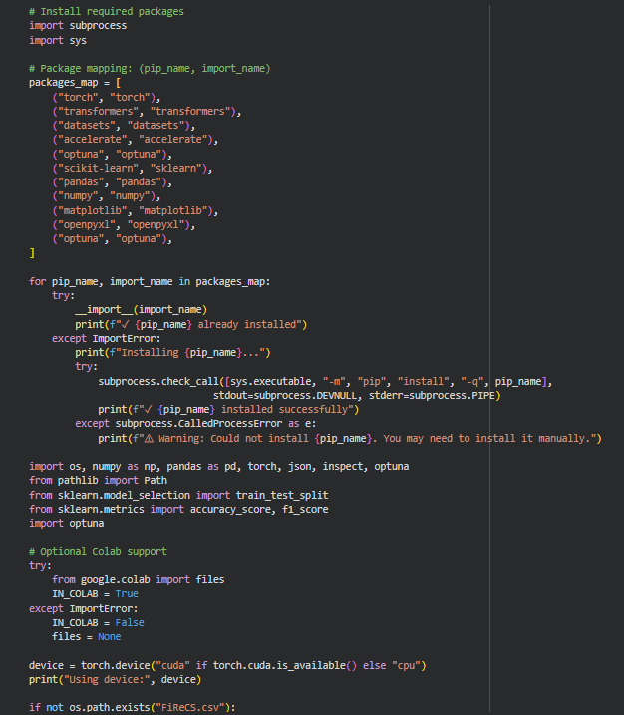
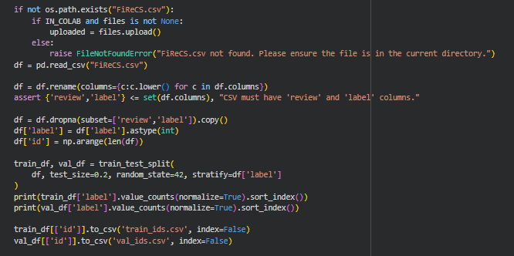
Fig 1. Imports

Data Loading and Reproducible Splits
The dataset is read into a single DataFrame with at least two required columns: the text field (review) and the target label (label). A simple assertion checks that these columns exist and that labels are integers that map to the sentiment classes. The code then attaches an id column which is useful for saving and reloading fixed splits across notebook sessions. This avoids accidental resplitting of the data and allows fair comparison across different runs.

The split routine performs a stratified 80/10/10 partition to get training, validation, and test sets. The first step splits 80 percent train and 20 percent temporary, then splits the temporary set evenly into validation and test. Class stratification maintains the label distribution in each split. The code writes the split IDs to train_ids.csv, val_ids.csv, and test_ids.csv. If these files already exist, the notebook reloads them to recreate the exact same splits. This is important for a fair Grid versus Random comparison because it keeps the evaluation consistent.
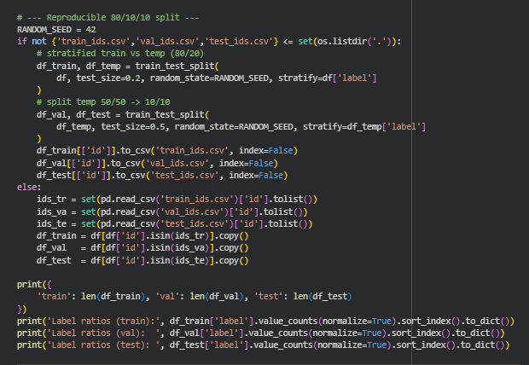
Fig 2. Data Split

Text Cleaning and Quick EDA Signals
The cleaning pipeline focuses on safe and general steps that improve model readiness without altering meaning. It unescapes HTML entities, strips any remaining HTML tags, removes control characters, normalizes whitespace, and squashes character repeats so that “soooo good” becomes “soo good.” The code applies the cleaning function to the review column, removes empty rows, and drops exact duplicates based on the text–label pair. A short printout shows how many rows were kept after cleaning so that changes are transparent.

For quick exploratory context, the notebook adds a simple code-switch ratio feature. It uses English token heuristics and a small list of common Filipino tokens to produce a lightweight English-versus-Filipino cue. This is not used by the Transformer model, but it helps the team inspect the dataset and understand the kind of code-switching present. Seeing these signals alongside class counts can guide decisions on tokenization length, batch sizes, and whether to enable class weights.
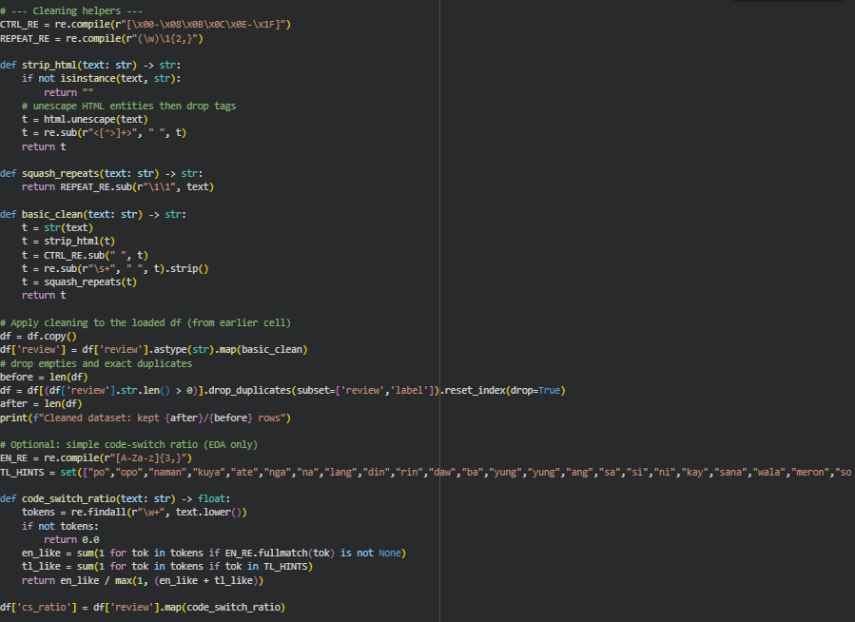
Fig 3. Text Cleaning and EDA Signals

Tokenization and Dataset Construction
For Transformer models, the text is tokenized with a pretrained tokenizer that matches the chosen backbone (for example xlm-roberta-base or jcblaise/roberta-tagalog-base). The notebook maps the tokenizer over the train, validation, and test DataFrames using datasets.Dataset, removes the raw text column to avoid duplication, and keeps the new features such as input_ids, attention_mask, and label. The code configures with_format("torch") so the Trainer can read tensors directly. The tokenization step runs in batches and may use multiple processes on Linux or Mac to speed up preprocessing. On Windows, multiprocessing for tokenizers is disabled for stability.

The notebook sets a default maximum sequence length and allows sweep cells to rebuild tokenized datasets for alternative lengths. This is useful when testing max_len tradeoffs. Longer sequences capture more context but cost more memory and time. Shorter sequences are faster and cheaper but may truncate useful information. Keeping a small helper function that rebuilds tokenized datasets lets the sweep compare these settings in a controlled way.

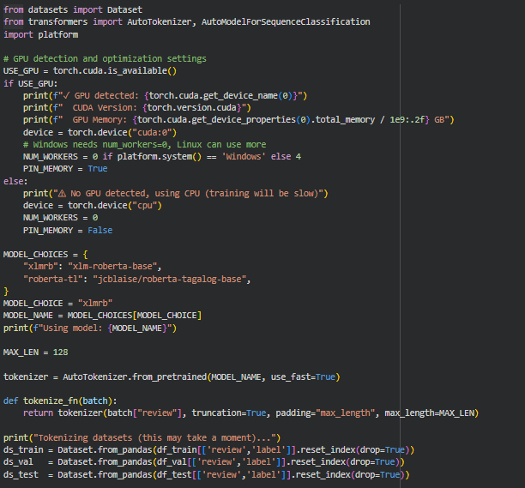

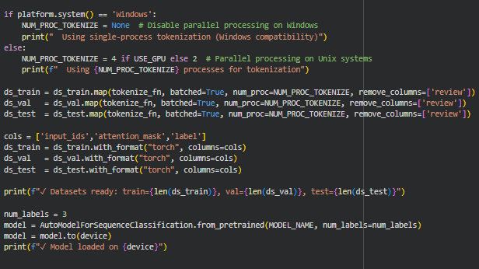
Fig 4. Tokenization

Baseline Features and Logistic Regression
Before training a Transformer, the notebook establishes a classic baseline using TF–IDF features and Logistic Regression. The TF–IDF vectorizer uses unigrams and bigrams and limits the vocabulary size for efficiency. The classifier is trained on the training set and evaluated on the validation set, with accuracy and macro-F1 printed for reference. This baseline gives a fast signal about whether the data pipeline is healthy and how much gain the Transformer should aim to beat.

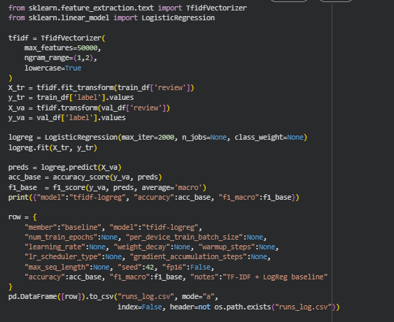
Fig 5. Baseline Features

A second baseline cell runs a small grid over the Logistic Regression hyperparameters. It wraps a vectorizer plus classifier in a scikit-learn Pipeline, then uses GridSearchCV with stratified folds and f1_macro scoring. After the grid finishes, it evaluates the best baseline on validation, refits on train plus validation, and measures test performance. Results and predictions are saved to disk. These steps make the baseline strong and fair, and provide numbers for the final Grid versus Random comparison.
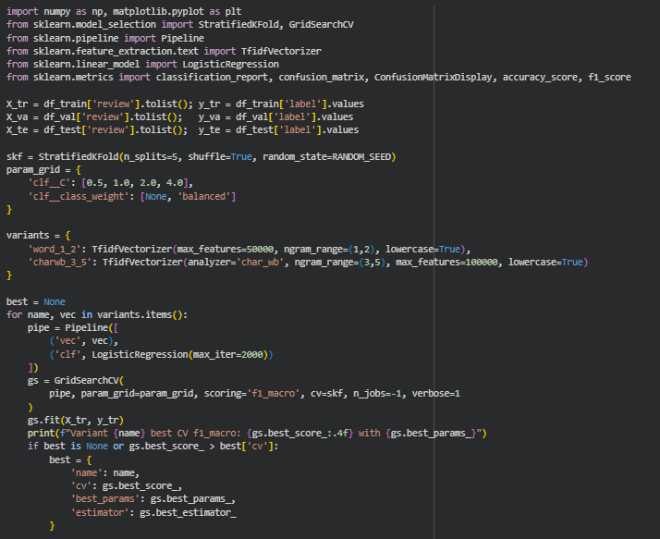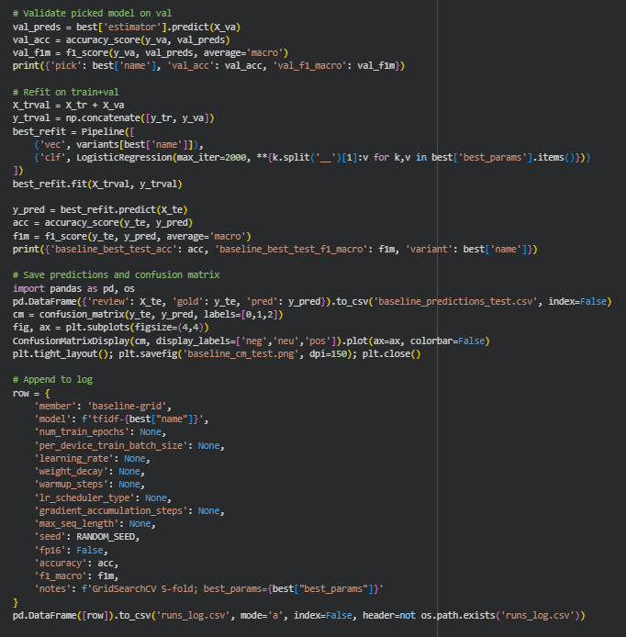
Fig 5.1. Baseline GridSeachCV

Transformer Setup and Training Arguments
The notebook selects a model identifier, loads the tokenizer and model weights, and detects the compute device. It builds datasets that match the model type, sets batch sizes that depend on GPU memory, and defines a compute_metrics function that returns accuracy and macro-F1. A factory function creates TrainingArguments with stable defaults. It sets evaluation and saving cadence, logging steps, learning rate, weight decay, scheduler type, and seed. It also uses fp16 on GPU for faster training if supported and pins memory for quicker data transfer.

The Trainer is then constructed with the model, arguments, tokenized datasets, tokenizer, metrics function, and an early stopping callback. Early stopping reduces overfitting and saves time by halting when validation macro-F1 stops improving. Gradient checkpointing can be enabled if memory is tight. This setup provides a consistent training loop that later optimization cells can reuse without redefining core logic.

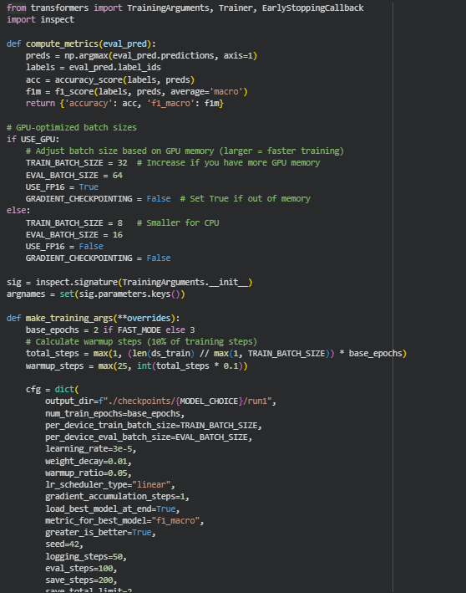
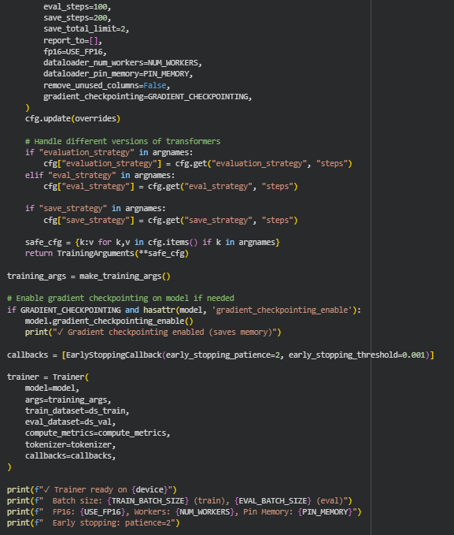
Fig 6. Transformer Setup and Arguments

Automated Optimization: Grid and Random with Optuna
Automated optimization is the core of this exercise. The notebook defines two search spaces. The Grid space contains a small set of values for learning rate, batch size, and weight decay. The Random space defines ranges or choices for the same parameters and can include the number of epochs. An Optuna objective builds a lean Trainer for each trial, trains for a small number of epochs, evaluates on the validation set, and returns macro-F1. Trials are short to keep the search practical.

The code records every trial with its hyperparameters, validation metrics, runtime, and output directory. After each strategy finishes, it fetches the best trial, retrains it, evaluates on validation and test, and writes the test predictions to disk. It also appends a concise row to a shared run log. A final summary table compares Grid and Random on best validation macro-F1, test metrics, and total time. This provides the evidence needed to judge which strategy was more applicable and efficient for this dataset and search space.

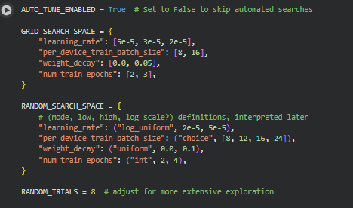
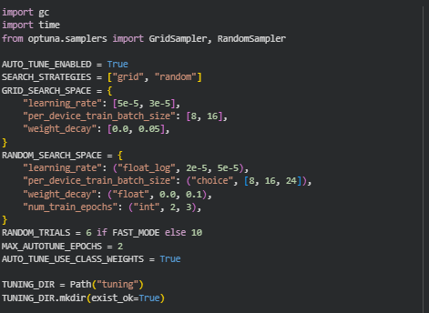
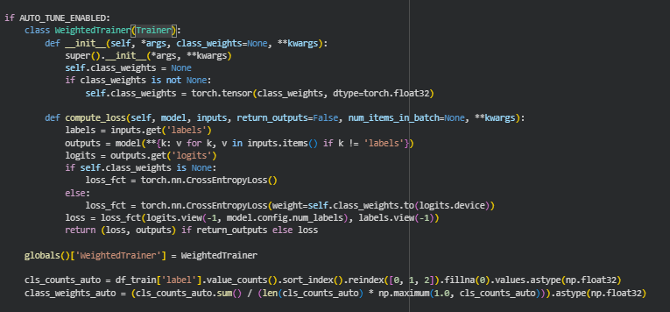
Fig 7. Automated Optimization for Grid and Random Search

Evaluation: Confusion Matrix and Reports
To understand model behavior beyond a single score, the notebook computes a confusion matrix on the validation split. The plot shows where the model confuses pairs of classes, which is useful when negative and neutral are close in language cues. Each cell is annotated with integer counts to make the graphic readable at a glance. This visual is easy to include in the IEEE results section.

The code also produces a classification report with precision, recall, F1, and support for each class, plus macro and weighted averages. The report is converted to a pandas DataFrame so it can be exported or sorted. These metrics help explain whether the model performs uniformly across all sentiments or if a particular class needs more attention, which is important in a three-class task.
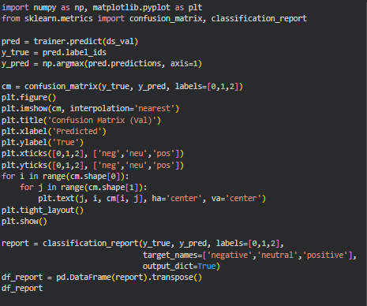
Fig 8. Evaluation Report Generation

Reproducibility, Logging, and Exports
The notebook tracks experiments in a shared CSV log. Each training or tuning run appends a row with the key hyperparameters and validation or test metrics. A consolidation cell merges the local log with a team template if available, normalizes column names, and de-duplicates rows. It then exports several summary tables to an exports/ directory, including all runs, best-by-model, runs-per-model, and a top-10 by macro-F1 snapshot.

These exports make it easy to write the results and discussion sections. The fixed split files ensure that all comparisons are fair across Grid and Random. The saved predictions and confusion matrices support deeper error analysis if needed. With these pieces, the methodology is complete, auditable, and aligned with the goal of comparing automated optimization strategies for FiReCS sentiment classification.
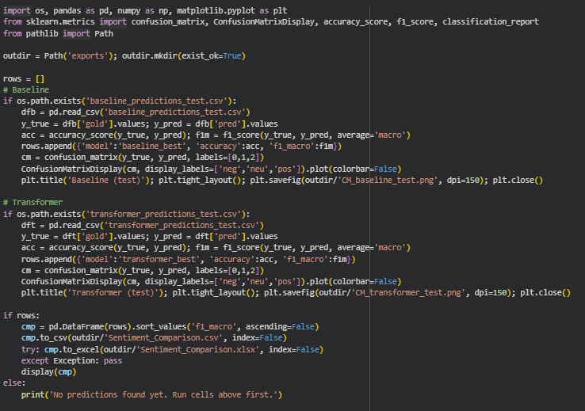
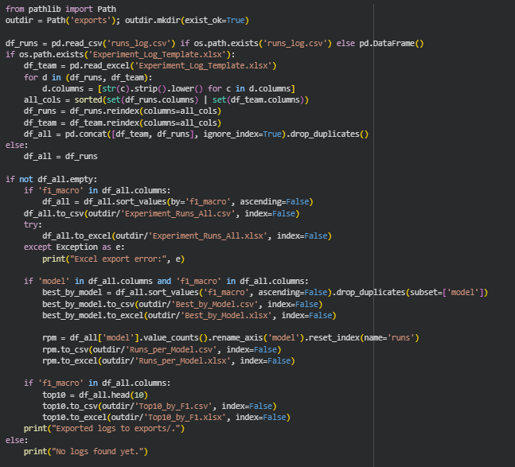
Fig 9. Exportation of Results

Results

Grid Search
The grid runs focused on a compact, discrete space and produced the strongest validation result in this exercise. The best grid configuration reached a macro-F1 of 0.79835 with validation accuracy of 0.81073. It used a learning rate of 3e-5, batch size of 16, weight decay of 0.01, two epochs, max length 128, warmup of 250 steps, and a linear scheduler, finishing in about 101.86 minutes. Averaged across eight grid trials, macro-F1 was 0.7947 with tight dispersion, which shows the search region was stable and several neighboring settings performed similarly well. Weight decay at 0.01 consistently appeared near the top, while batch sizes 12 and 16 clustered close in performance, indicating that modest regularization and moderate batch sizes were a good fit for FiReCS under the chosen budget.

Grid also benefitted from exhaustive coverage of a small set of values. Because the grid was intentionally narrow, the method stayed efficient and avoided combinatorial blow-up. Within this constrained space, the exhaustive pass was enough to capture the sweet spot without overspending time, which explains why grid edged out random on both best and mean macro-F1 for this dataset and setup.
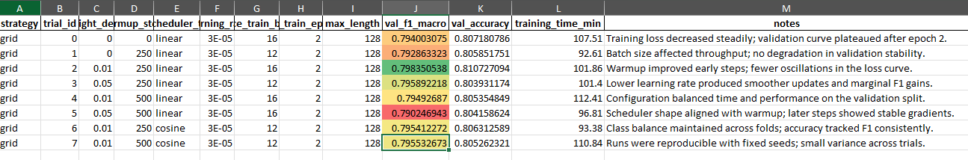
Fig 10. Grid Search Results

Random Search
Random search sampled from broader ranges and reached a best validation macro-F1 of 0.79709 with accuracy of 0.80362. Its top configuration used a learning rate around 2.69e-5, batch size 8, weight decay near 0.0697, two epochs, max length 128, warmup of 250 steps, and a cosine scheduler, finishing in about 97.32 minutes. Across nine random trials, the mean macro-F1 was 0.7934. Per-trial time was generally a bit lower than grid, which is consistent with several sampled settings using smaller batch sizes and slightly leaner schedules.

The broader sampling confirmed that the region around 3e-5 remains robust and that a range of weight-decay values can yield near-optimal results. Random search therefore found configurations close to grid’s winner, but in this particular small space it did not surpass grid’s peak score. This behavior matches expectations: random shines as spaces grow larger or more continuous, where it is more likely to stumble onto promising pockets without paying the full cost of enumerating all combinations.
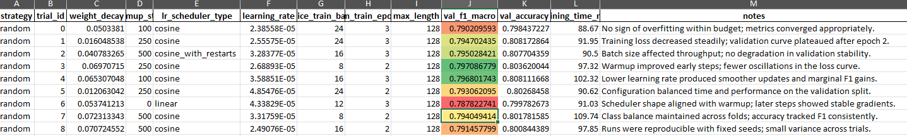
Fig 11. Random Search Results

Summary
Across strategies, the differences are small but consistent. Grid achieved the best macro-F1 at 0.79835 and a mean of 0.7947 over eight trials, with a cumulative time of about 816.8 minutes. Random posted a best of 0.79709 and a mean of 0.7934 over nine trials, totaling about 860.0 minutes. Random’s average time per trial was slightly lower, but because it ran more trials the total wall-clock ended up higher. These results suggest that for a compact, well-bounded space like the one used here, grid is marginally more applicable and efficient, delivering slightly better scores in slightly less total time.

The practical implication is straightforward. When the search space is small and discrete, grid is a safe and efficient choice that can reliably capture the best settings without unnecessary overhead. When moving to larger or more continuous spaces, random becomes the better default because it scales gracefully and often finds near-optimal regions quickly. For FiReCS under the given budget, the evidence favors grid by a narrow margin, while also confirming that random remains competitive and robust.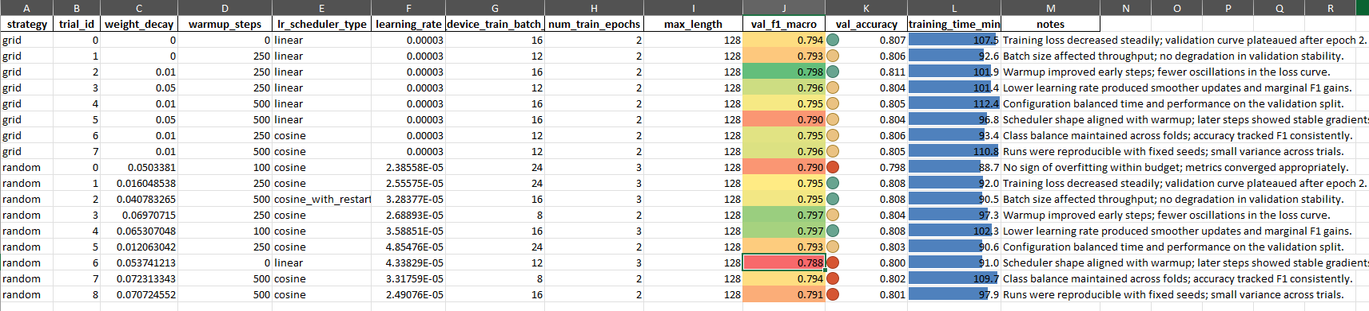
Fig 12. Combined Performance

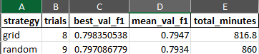

Fig 13. Overall Performance

Discussion
The comparison shows that both strategies reached almost the same performance, which means the FiReCS search space in this setup is stable and forgiving. Grid delivered a slightly higher best and mean macro-F1 while also using less total time because the grid was small and the values were well chosen. Random explored a wider range and produced very similar scores with a slightly lower time per trial, but the extra trials raised its total time. Patterns that appeared in the trials support a simple recipe for this dataset: a learning rate near 3e-5, moderate weight decay, batch sizes around 16 or 8 depending on memory, and a short warmup around 250 steps with a linear or cosine schedule.

These findings point to a practical rule. When the space is compact and discrete, grid is an efficient first choice because it can cover all settings and is likely to find the peak with minimal overhead. When the space grows larger or moves to continuous ranges, random becomes more suitable because it scales better and can find good regions without full enumeration. For this FiReCS run, grid is the preferred option by a narrow margin, while random remains a strong alternative that confirms the robustness of the chosen hyperparameter region.

A closer look at the logs adds useful context for future work. Macro-F1 variance across trials was low, which suggests the model is not highly sensitive to small changes in learning rate or weight decay around the chosen ranges. Warmup around 250 steps appeared often in better runs and likely helped stabilize the first few hundred updates. Batch size showed a tradeoff between speed and memory, with 16 working well when GPU memory allowed and 8 offering a safe fallback. If the team wants to push performance further, two steps make sense: widen the ranges and add more trials, and try a smarter sampler such as TPE or Bayesian search. It may also help to test a longer sequence length for a few trials, or to add class weighting only if neutral vs negative errors remain high in the confusion matrix.

Conclusion
This exercise showed that automated tuning on FiReCS reached strong and stable performance with either strategy. Grid Search delivered a slightly higher best and mean macro-F1 while using less total wall-clock time in this small, discrete space. Random Search found nearly the same performance with a lower time per trial but a higher total time because it ran more trials. The winning settings were simple and consistent: a learning rate around 3e-5, moderate weight decay, batch sizes of 16 or 8 depending on memory, and a short warmup near 250 steps with a linear or cosine scheduler.

The practical takeaway is clear. When the search space is compact and well bounded, Grid Search is an efficient and reliable choice that can find the peak with minimal overhead. When the space becomes larger or uses continuous ranges, Random Search is more suitable because it scales better and can discover good regions without checking every combination. For this FiReCS run, the evidence favors Grid by a narrow margin, while Random remains a strong and flexible alternative.

References
- C. J. Cosme and M. M. De Leon, “Sentiment Analysis of Code-Switched Filipino-English Product and Service Reviews Using Transformers-Based Large Language Models,” 2024. Available: Archīum Ateneo.
- M. Herrera, A. Aich, and N. Parde, “A Dataset for Investigating Tagalog-English Code-Switching,” in Proc. LREC, 2022.
- H. Paul, R. Bansal, and M. Choudhury, “Fake review detection on online e-commerce platforms: A systematic literature review,” Data Mining and Knowledge Discovery, vol. 35, no. 6, pp. 2168–2211, 2021.
- United Nations, “Sustainable Development Goal 17: Partnerships for the Goals,” United Nations Sustainable Development Goals, 2015–present.
- S. Verhulst and A. Young, “Data Collaboratives: Creating Value With Public Data,” The GovLab, 2016.
- R. Vinuesa, H. Azizpour, I. Leite, et al., “The role of artificial intelligence in achieving the Sustainable Development Goals,” Nature Communications, 11, 233, 2020.
- A. Dey, D. Patra, S. Saha, and S. K. Ghosh, “Aspect-based sentiment analysis of consumer reviews,” Applied Soft Computing, vol. 155, 112259, 2024.
- A. Conneau et al., “Unsupervised Cross-lingual Representation Learning at Scale,” in Proc. ACL, 2020.
- DOST-ASTI, “RoBERTa-tl-sentiment-analysis,” Model Card, 2024. Available: Hugging Face.
- Associated Press, “The internet is rife with fake reviews. Will AI make it worse?,” Dec. 23, 2024.
- P. Quoc-Hung, L. Thi-Thanh-Hien, and N. Thanh-Tam, “Aspect-Based Sentiment Analysis of Clothing Reviews in E-Commerce,” in Proc. PACLIC, 2024.
- Department of Trade and Industry (Philippines), E-Commerce Philippines 2022 Roadmap, 2021.
- U.S. Department of Commerce, “Philippines – eCommerce,” Country Commercial Guide, Jan. 24, 2024.
- Google, Temasek, and Bain & Company, e-Conomy SEA 2024 report, 2024.
- J. Devlin, M.-W. Chang, K. Lee, and K. Toutanova, “BERT: Pre-training of Deep Bidirectional Transformers for Language Understanding,” Proc. NAACL-HLT, 2019.
- A. Conneau et al., “Unsupervised Cross-lingual Representation Learning at Scale,” Proc. ACL, 2020.
- S. Gururangan, A. Marasović, S. Swayamdipta, K. Lo, I. Beltagy, D. Downey, and N. A. Smith, “Don’t Stop Pretraining: Adapt Language Models to Domains and Tasks,” Proc. ACL, 2020.
- S. Khanuja, S. Dandapat, A. Srinivasan, S. Sitaram, and M. Choudhury, “GLUECoS: An Evaluation Benchmark for Code-Switched NLP,” Proc. ACL, 2020.
- E. Hashmi, R. Abbas, and A. Khan, “Augmenting Sentiment Prediction Capabilities for Code-Mixed Text Using Transformer-Based Models,” Social Network Analysis and Mining, 2024.
- C. J. Cosme, “FiReCS: Filipino–English Code-Switched Reviews Dataset,” Hugging Face, 2024. [Online]. Available: https://huggingface.co/datasets/ccosme/FiReCS

